Big-bang Integration Testing

📖 Definition
# Source: AI Source: Provided by: [Data Path: Persons Table -> ID Column: 1, Name_En Column: Motasem Essam] -> From: [Chatgpt (GPT‑5 Mini)] on [8/23/2025]
Big-bang Integration Testing is an approach where all components/modules are combined together at once, after unit testing is complete, and then tested as a whole system.

🔹 Characteristics
# Source: AI Source: Provided by: [Data Path: Persons Table -> ID Column: 1, Name_En Column: Motasem Essam] -> From: [Chatgpt (GPT‑5 Mini)] on [8/23/2025]
- No incremental integration.
- Testing starts only after all modules are developed and unit tested.
- The entire system is tested in one go.
- Often used when the system is small or simple, or when there is not enough time for step-by-step integration.

🔹 Objectives
# Source: AI Source: Provided by: [Data Path: Persons Table -> ID Column: 1, Name_En Column: Motasem Essam] -> From: [Chatgpt (GPT‑5 Mini)] on [8/23/2025]
- Validate that the complete system works after all components are integrated.
- Quickly see how the system behaves as a whole.

🔹 Example
# Source: AI Source: Provided by: [Data Path: Persons Table -> ID Column: 1, Name_En Column: Motasem Essam] -> From: [Chatgpt (GPT‑5 Mini)] on [8/23/2025]
Using the ATM system example again:
- Modules:
  - A = User Interface
  - B = Account Management
  - C = Transaction Processing
  - D = Balance Inquiry
  - E = Withdrawal
  - F = Deposit
🔹 In Big-bang approach:
- First, all modules (A, B, C, D, E, F) are developed and unit tested separately.
- Then, integrate them all together at once.
- Perform system-level tests on the complete integrated product.

🔹 Advantages
# Source: AI Source: Provided by: [Data Path: Persons Table -> ID Column: 1, Name_En Column: Motasem Essam] -> From: [Chatgpt (GPT‑5 Mini)] on [8/23/2025]
- Simple → No need for drivers/stubs.
- Suitable for small systems where interactions are not complex.
- Quick system integration if development is short.

🔹 Disadvantages
# Source: AI Source: Provided by: [Data Path: Persons Table -> ID Column: 1, Name_En Column: Motasem Essam] -> From: [Chatgpt (GPT‑5 Mini)] on [8/23/2025]
- Difficult to isolate defects (if something fails, it’s hard to know which module caused it).
- High risk → if integration issues exist, many defects may appear at once.
- No early prototype → customers cannot see progress until the very end.
- Debugging and fixing can take a lot of time.

⚖️ Summary Table (Big-bang vs Incremental Approaches)
# Source: AI Source: Provided by: [Data Path: Persons Table -> ID Column: 1, Name_En Column: Motasem Essam] -> From: [Chatgpt (GPT‑5 Mini)] on [8/23/2025]
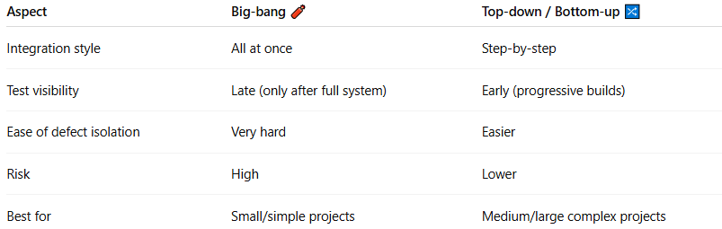
Aspect | Big-bang 🧨 | Top-down / Bottom-up 🔀
Integration style | All at once | Step-by-step
Test visibility | Late (only after full system) | Early (progressive builds)
Ease of defect isolation | Very hard | Easier
Risk | High | Lower
Best for | Small/simple projects | Medium/large complex projects

✅ In short:
Big-bang Integration Testing = Combine everything at once after unit testing → test the full system together → simple but risky.

